Game N' Watch: Initial Project Concept
John Reese, Benjamin Roux, Andrew Storrow
9/13/07

The primary purpose of the application will be to track all upcoming video games that are being released. Users will be able to view a list of all games to be released and search/sort it however they wish. An example might be that a user wants to see all games being released in a given month or all games of a given genre. Users will then be able to select games they are interested in or own and form a list of games stored in their profile. The application will then be able to perform actions on this list such as email notifications when a games release date approaches, news related to the game or if the release date changes, recommend similar games and more.

Users will have the ability to find and make friends with other users based on common interest in games and genres, and share their owned and upcoming game lists with other users. There will be also be a financial section of information relating to a game such as units sold, total profit made, development costs, etc. Shareholders and any other interested users will be able to view this information and track how it changes.

There will be a substantial data backend to the application containing data pertaining to the games and users of the system. Data kept on a given game may include game name, release date, genre, platform, similar games, financial info and more. User info kept would include a user name and the list of games they are interested in. Moderators of the system will be able to enter new games into the database and modify their info using the application. Specific reports could be generated with info such as how many users are tracking which games or which games have made the most profit.

The project will be utilizing a Java-based set of enterprise technologies to power the system for the presentation and business tiers of the application in a platform-independent manner, so that it may be hosted on a wide variety of hardware or environments without modification. The middle tier, which will provide the core logic of the system, will use the lightweight Spring Framework version 2.0, while the website tier will use the Spring MVC web framework to better integrate with the backend. The JSP webpages will be served using the Apache Tomcat version 5.0.

The website's data will be stored and hosted using the MySQL relational database management system, which offers a cross-platform and scalable database architecture. The stored data will be accessed using the Spring Framework's JDBC implementation, so that other database vendors may be chosen for deployment depending on situational needs and other criteria.
For development tools, the project is stored in a Subversion repository for version control, with an integrated Mantis bugtracker for project management and issue reporting. The project itself uses a set of automated Ant scripts for building and deploying the project to the testing server. With this setup, developers can work autonomously and on concurrent portions of the application without threat of conflicts when submitting changes to source control.

In terms of risk management, due to the nature of the system, one of the major risks is the accessibility of the system. The application will have to be made such that it is both robust and can remain active for long periods of time. Another foreseeable risk is that user data be securely stored. As a database of user profiles containing a myriad of data, address and email included, it is very important that this data is not accessible by anyone, nor is there and easy way to automate the collection of all this data from an outside user.

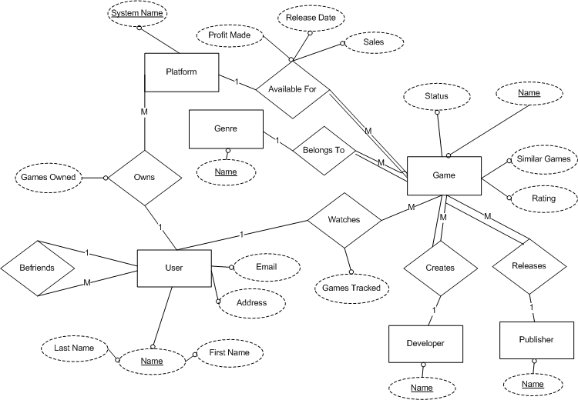
We plan to handle these risks by paying extra attention to both exceptions and security. As an information system, it is essential that the application remains active for long periods of time, and we cannot have it crashing from various exceptions that may or may not arise during its execution. Also, in user securities, by securing the database and handling the data appropriately in the application layer of our system, we feel we can ensure the safety of our user’s information.

